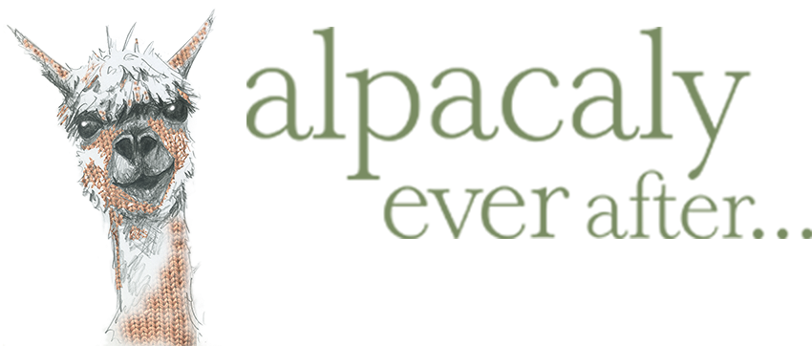

Grow Wild Project

Spring 2025

The Grow Wild Project at Basecamp North Lakes involves nature-based activities and connection with self and others to promote wellbeing and help with physical, mental or social health conditions.

Please complete and return the booking form if you would like to attend the sessions.

**Booking Form**

|  |
| --- |
| Name: |
| Address: |
| Mobile telephone number: |
| Work or home telephone number: |
| Date of birth: |
| E-mail address: |

|  |
| --- |
| **Emergency Contact Details** |
| Name: |
| Address: |
| Mobile telephone number: |
| Work or home telephone number: |
| E-mail address: |

|  |
| --- |
| Grow Wild sessions are funded by the National Lottery for those people who will benefit. Please briefly answer the following questions to help us shape the project to need the needs of the group.     1. What challenges do you face (physical, mental, social)?   2. How might you benefit from attending the Grow Well project? |

|  |
| --- |
| **Medical Information** |
| Family Doctor: |
| Telephone number: |
| Medical History including information about: Diabetes, Asthma, Heart trouble, Bleeding/clotting, Other. |
| Allergies (please provide further information if you have or have had allergies including: Bee stings, Medications, Food and Drink, Other. |
| Please note any current information: |

|  |
| --- |
| Any other information that we need to be aware of (emotional, behavioural, learning difficulties, additional needs etc.): |
| Any restrictions we need to know of when participating in physical activities: |
| Would you like to borrow waterproofs and wellies for the session? If so, please note shoe size. |
| We will occasionally provide some snacks during the sessions. Are there any dietary requirements that we should be aware of? |
| Photographs consent: Photographs of our activities are really valuable to us for use in publicity including our web page, social media, displays and leaflets. We will NOT use a child’s name with an image. It also provides evidence of the positive work we are doing. Please feel reassured that we would not pass the photos on to anyone else therefore would like your consent in allowing us to use any photos taken for the purposes listed. If you DO NOT consent, please do not sign this section.  I **consent** to photographs being used for promotional purposes.  Signed:    Name print:  Date: |
| **Form filled in by**  Name print:  Relationship to child/young person:  Date: |

Thank you for your interest in the Grow Wild project. We will be in touch to confirm your place. Should you have any questions, please contact us at: [garden@alpacalyeverafter.co.uk](mailto:garden@alpacalyeverafter.co.uk)